Name_____________________________
Date____________________
Period_________
Unit #2 Vocabulary Flipbook Project
Read over the following vocabulary terms, and then put a check in the column that best describes your understanding of the term.
 | I know what this is | I have heard it but am not sure of the meaning | This is new to me
Astronomy
Atom
Authority
Claim Testing
Collective Learning
Cosmic Background Radiation (CBR)
Evidence
Gravity
Hydrogen
Intuition
Light-Year
Logic
Nucleus (atomic)
Proton
Telescope

Now that you have completed and correctly defined all of the vocabulary terms for Unit #2, you are going to create a “Unit #2 Vocabulary Flipbook”. For this mini-project, you will complete all of the following:
1.) On the front cover write the title, “Unit #2 Vocabulary Flipbook” by: Your Name.
2.) On each of the pages, you will have:
a.) The Term
b.) The Definition
c.) A picture that goes along with the term.
3.) Be sure to have plenty of bright, bold color in each of your pictures.
Example:
Telescope
An instrument used for viewing distant objects, including planets, stars, and galaxies.
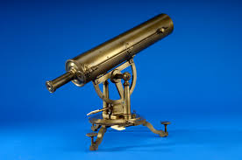

This mini project will be due on Tuesday, October 3, 2017.
Unit #2 Vocabulary Flipbook Project Rubric
Evidence | Exceeding | Meeting | Approaching | Beginning
Identify sources that support my claim. | I can identify two pieces of evidence to support the claim from a source(s) my teacher gave me. | I can identify one piece of evidence to support the claim from a source(s) my teacher gave me. | I can try to identify one piece of evidence to support the claim from a source(s) my teacher gave me. | I can try to identify a piece of evidence from a source given by my teacher.

