Unit 4 The Earth & Solar System Vocabulary
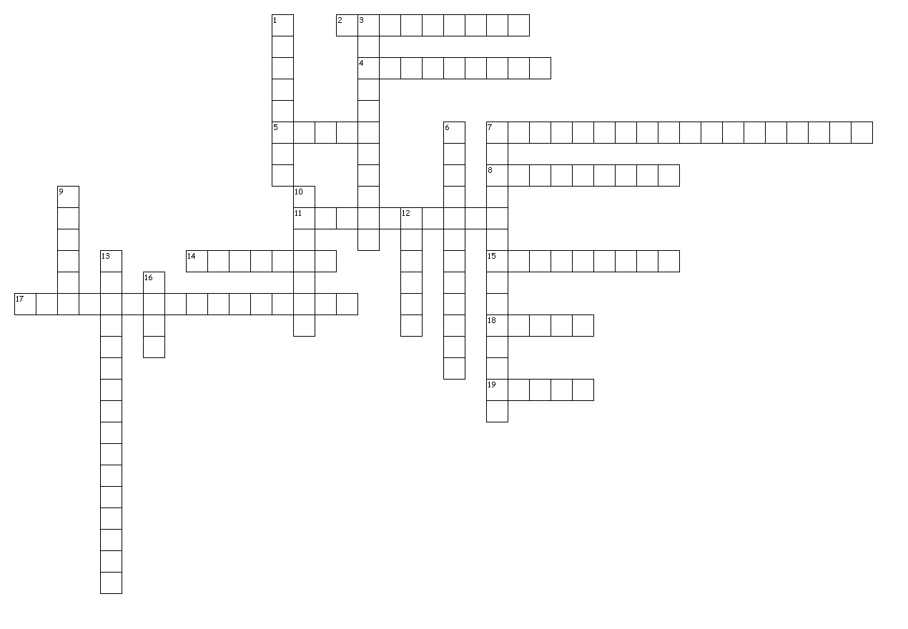
Across
2. The first eon when the Earth was still forming and not suitable for life.
4. Rhythm Master clock controlling the body's systems based on the sun's 24-hour cycle.
5. The layer of the Earth's atmosphere that shields it from the Sun's radiation.
7. Gas and dust around a star that forms into planets.
8. The formation of planets as they orbit stars.
11. A mixture of gases that form around a planet.
14. The scientific study of the Earth's past.
15. Planets outside of our solar system.
17. The process by which gases trap heat around the Earth's surface.
18. The path of a body through space, often dictated by gravitational pull.
19. The solid outer layer of the Earth consisting mostly of moving plates.
Down
1. Small rocky, icy, and metallic bodies leftover from the formation of the solar system.
3. The second eon in Earth's history when the first organisms appeared.
6. An object smaller than a planet that forms during accretion, and may later form into a planet.
7. The idea that the Earth's crust rests on plates that are continually moving.
9. The layer of the Earth between the crust and core that is mostly flowing, causing plates to move.
10. The vast supercontinent that existed 200 million years ago.
12. A spherical ball of rock, gas, or both that is in an orbit around a star.
13. The idea that the continents are continually moving and were once connected.
16. The dense center of the Earth that is made of mostly iron and some nickel.

