Name_____________________________
Date____________________
Period_________
Unit #8 Vocabulary Flipbook Project
Read over the following vocabulary terms, and then put a check in the column that best describes your understanding of the term.
 | I know what this is | I have heard it but am not sure of the meaning | This is new to me
Barter
Black Death
Carrying Capacity
Colonization
Columbian Exchange
Exchange Network
Globalization
Holocene Epoch
Hub Region
Industrial Revolution
Malthusian Cycles
Modern Revolution
Silk Roads
Steam Engines
World Zone

Now that you have completed and correctly defined all of the vocabulary terms for Unit #8, you are going to create a “Unit #8 Vocabulary Flipbook”. For this mini-project, you will complete all of the following:
1.) On the front cover write the title, “Unit #8 Vocabulary Flipbook” by: Your Name.
2.) On each of the pages, you will have:
a.) The Term
b.) The Definition
c.) A picture that goes along with the term.
3.) Be sure to have plenty of bright, bold color in each of your pictures.
Example:
Barter
To trade goods or services for equivalent goods or services without an exchange of money.
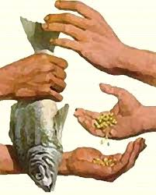

This mini project will be due on __________________________________ and worth 500 points.
Unit #8 Vocabulary Flipbook Rubric
_____/425 The flipbook contains each of the 15 terms with the correct definition and a picture.
_____/25 The flipbook has the title, “Unit #8 Vocabulary Flipbook” by: Your Name.
_____/50 The flipbook has plenty of bright, bold color.

_____/500 Total Points _____ % _____ Letter Grade

