What Did Stars Give Us Video Questions
As you watch the each of the videos, answer the following questions:
Threshold 3: New Chemical Elements
Questions | Notes
How did we get elements other than hydrogen and helium? | - What was the universe like 200 million years after Threshold #2?  - What atomic matter existed in the universe, and what type of matter were they?  - What does inert mean?  - Why was this a problem?  - What did the universe need?  - What ingredients were needed for new chemical elements?  - Explain how aging and dying stars create new elements?  - What is created by a supernova?  .  - What are the Goldilocks Conditions for New Chemical Elements?
Summary (What is the BIG idea presented in the video):

What Did Stars Give Us?
Questions | Notes
What elements are produced in aging and dying stars?  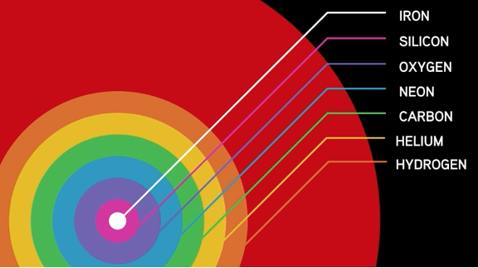 | - Where did all the other elements come from?  - What did the cooling of the universe allow?  - How hot is the surface of the sun?  - What temperature do you need to get Carbon? To get Iron?  - What happens as stars begin to run out of fuel?  - What is a supernova, and what does it do?  - What might the star of Bethlehem have been?  - Compare the percentage of Hydrogen and Helium to all other elements.
Summary (What is the BIG idea presented in the video):

