What is Big History Video Questions
Questions | Notes
What is Big History and how is it different from other history courses?  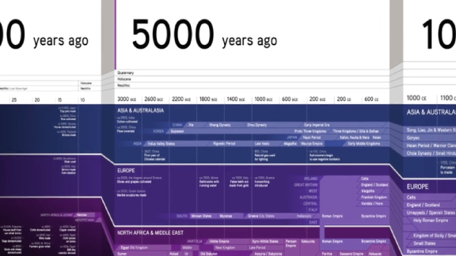  Hold down Control + Click on the picture above to watch the video. | - 1:28 David Christian emphasizes the importance of questions in the course. What are some of the questions he identifies?  - 2:04 What is Big History?  - 3:21 What kinds of questions did David Christian ask as a result of his thinking about the teaching of one country’s history? How did these questions lead him back to the origins of the Universe?  - 4:08 What are origin stories?  - 4:18 What is Big History? (Teacher note: This is the second time David Christian defines Big History. You can stop a second time for emphasis, or continue without stopping.)  - 6:19 What are “thresholds of increasing complexity”?
Summary (What is the BIG idea presented in the video):

