Where & Why Did the First Cities and States Appear
As you watch the video, answer the following questions about our early city and states.

Questions | Notes
Where & why did the first cities and states appear?  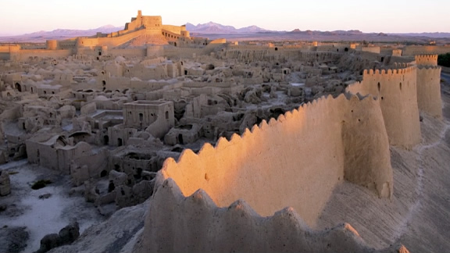 | Part I  1.) 0:55 Why does David Christian claim that increasing complexity depends on agriculture?  2.) 2:00 What was the “secondary products revolution” and why was it so important to the spread of agriculture and the growth of cities and states?  Part II  3.) 3:34 What is an agrarian civilization?  4.) 3:50 Where did the first agrarian societies develop?  5.) 5:02 Why does David Christian say that "surpluses" are the key to cities?  6.) 5:30 Why does Christian argue that cities needed a "coordinating mechanism"?  Part III  7.) 7:22 What are the characteristics that all agrarian civilizations share?  8.) 8:05 Why does David Christian make the claim that writing accelerated collective learning? Do you agree with him?
Summary:

