World Zones Reading Questions
Questions | Notes
What are World Zones?  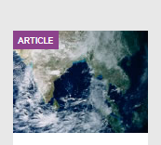 | 1.) What is a world zone?  2.) What advantages did the Afro-Eurasian world zone have over the other world zones?  3.) What were some of the disadvantages that the Australasian and Pacific world zones faced?
Summary (What is the BIG idea presented in the reading):

